A

PROJECT

REPORT

ON

**HOME**

**AUTOMATION**

**USING**

**FPGA**

Under

the

guidance

of

Dr.

Rekha

S

Submitted

by

Radhika

(221

EC

143)

and

Bhoomika

(221

EC

136)

DEPARTMENT

OF

ELECTRICAL

AND

COMMUNICATION

ENGINEERING

NATIONAL

INSTITUE

OF

TECHNOLOGY

SURATHKAL,

KARNATAKA



TABLE OF CONTENTS:

1. Abstract
2. Introduction
3. Motivation
4. Objectives
5. Literature review
6. Methodology
7. Work done
8. Results and Conclusion
9. References

Abstract

In recent years, the home automation has seen a rapid introduction of network enabled digital technologies. These technologies offer new and exciting opportunities to increase the connectivity of devices within the home for the purpose of home automation. In this report, we present the design and implementation of home automation system. Implemented using Verilog, our design integrates input from sensors to facilitate intelligent control of home appliances, enhancing convenience and efficiency. Through this project, we aim to explore the potential of home automation in improving standards of living and optimizing energy usage. This abstract provides a concise overview of our progress thus far, focusing on the technical aspects of the design and implementation process.

Introduction:

The past decade has witnessed a remarkable surge in the integration of networkenabled digital technologies into the realm of home automation. These advancements present many opportunities to revolutionize the way we interact with and manage our living spaces. In response to this trend, this report introduces a comprehensive exploration into the design and implementation of a home automation system.

Utilizing the versatility of Verilog and the flexibility of FPGA (Field Programmable Gate Array) technology, our project endeavors to establish a framework for the intelligent control of various household appliances. The integration of sensors enables the system to respond intelligently to environmental cues and user preferences, thereby enhancing convenience and efficiency within the home environment.

Our project also tries to delve into the broader implications of home automation. We seek to uncover the potential of these technologies in not only elevating standards of living but also in optimizing energy usage and promoting sustainable practices. Through this endeavor, we aim to contribute to the ongoing discourse surrounding the transformative power of home automation in shaping the future of residential living.

Motivation:

* Enhancing Daily Living:

Our project aims to simplify and enhance daily life experiences for homeowners through seamless control and coordination of home devices.

* Streamlined Convenience:

Automation enables devices to operate autonomously or interact with each other intelligently, eliminating the need for constant manual intervention. This streamlined approach to managing household tasks offers users unparalleled convenience.

* Fortifying Home Security:

By making use of smart devices such as smart locks and alarms, our project tries to enhances the security infrastructure of residential spaces. By providing enhanced monitoring and control capabilities, we strive to create a safer environment and instill peace of mind for homeowners.

* Promoting Sustainable Practices:

Through optimized energy usage and resource management, automation helps provide greater sustainability in residential living. By regulating appliance usage and minimizing wastage, our project aims to contribute to energy conservation efforts and promote eco-friendly lifestyles.

Objectives:

* To incorporate features such as: o **Smart Light Control**: To implement smart lighting system which controls the intensity of the light inside the house based on the intensity of the light entering the house. o **Temperature Control**: Integrating temperature sensors for controlling the temperature of the house.

o **Door Lock Automation**: Integrate smart door locks for locking and unlocking.

* To writing a program using Verilog, which is a Hardware Description Language, optimizing it to efficiently manage resources and implementing it on FPGA.
* Conduct thorough testing and validation processes to ensure the functionality, security, and performance of the home automation system under various scenarios.

Literature Review**:**

Home automation is the integration of technology and automation within a residential setting, which involves the management and control of various electronic devices and systems in a home to enhance convenience, comfort, energy efficiency, and security. Key aspects typically focused on in home automation include security features, lighting and temperature control, and the management of household appliances. These features are implemented to enable communication and trigger actions without any human interference.

Our project is based on [1]. The paper focuses on security and comfort features, including fire security, anti-burglary measures, and adjustable light and temperature control. These features are simulated using Verilog. The Verilog code mentioned in the paper is having a main module called Home_automation. It is connected to security and comfort modules. The security module contains the code which checks for the authenticity of the passcode input in order to open the door and also checks for any signs of burglary. This module is also responsible for ensuring that no fire has started in the house. The other module, the comfort module, is responsible for adjusting the ambiance of the house by regulating the temperature and lighting based on the external temperature and light intensity.

We have incorporated a few ideas from the aforementioned paper and developed a Verilog code that implements secure door locks, light control, and temperature management which form the basic and essential components. We have also further implemented the code on Nexys 4 DDR Artix 7 FPGA.

Methodology:

Home Automation involves the use of technology to control and automate household systems and appliances, such as lighting, heating, ventilation, air conditioning, security cameras etc. In our project, we have simulated a home automation system with the basic features which are lighting control, temperature control and smart locking system using Verilog. The flow chart representing the features is shown in Fig 1.

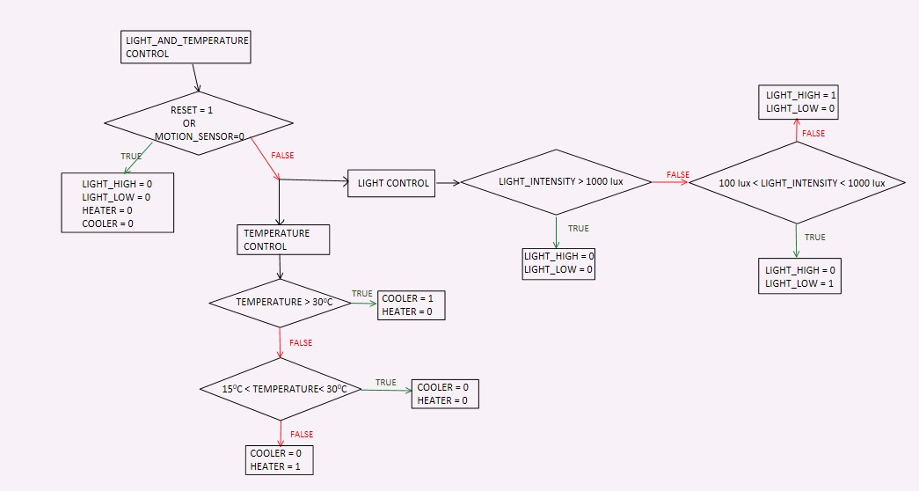

Fig 1.a: Flow Chart for lighting and temperature control

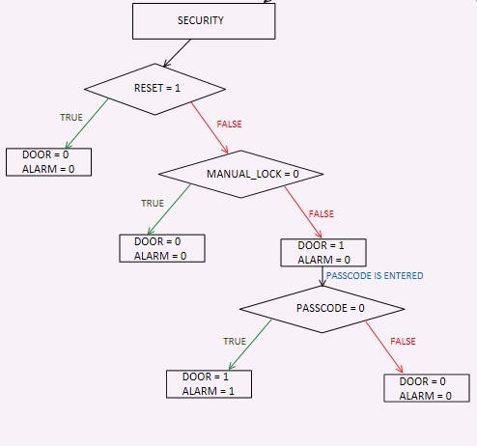

Fig 1.b: Flow Chart for Security features

The Verilog code comprises three modules: home_automation, light_and_temp, and security. The home_automation module acts as the main controller, calling the other two modules.

The light_and_temp module is responsible for managing the home's ambiance. It oversees two independent features: lighting and temperature control. The light intensity sensor serves as the input for controlling lighting. If the incoming light intensity exceeds 1000 lux, the house lights are turned off. If the intensity ranges between 900 lux and 100 lux, dim lighting is activated. If the light intensity falls below 90 lux, bright lights are switched on. Additionally, the module utilizes output from a temperature sensor to regulate indoor temperature. If the external temperature surpasses 30°C, the cooler activates; if it drops below 13°C, the heater turns on. Temperatures ranging from 15°C to 28°C result in both the heater and cooler being deactivated. Moreover, the lighting and temperature control system operates only when motion is detected within the house or room, facilitated by a motion sensor.

This ensures that lights and climate control devices are turned off when the space is unoccupied, thereby conserving energy.

The security module manages the smart locking system for the house. It relies on two primary inputs: manual_lock and passcode. A manual_lock value of 1 signifies that the door is locked. To unlock the door, the user must input a passcode. If the passcode is correct (i.e., passcode = 1), the door opens; otherwise, it remains locked, triggering an alarm.

Fig 2 shows the Verilog code and Fig 3 shows the output waveform obtained.

Work Done:

We have accomplished several key milestones in our project thus far. Firstly, we devised a flow chart illustrating the operations of a fundamental home automation system and translated it into a Verilog code to execute basic automation functions. Subsequently, we conducted initial testing of the code using a variety of input combinations. The Verilog code and the output obtained are shown in Fig 1 and 3 respectively.

It's important to note that the current iteration of our home automation system focuses solely on essential features. However, its capabilities can be enhanced by integrating additional functionalities, such as a fire detection system, anti-burglary measures, and control over various home appliances like sound systems and Wi-Fi routers. Furthermore, remote control of the system via mobile devices can be enabled, allowing users to manage their homes from anywhere.

After testing various test cases, we have implemented the code on FPGA(Field Programmable Gate Array) . In which we have executed the temperature module and security module. The pin configuration used is as follows: alarm- T8, clock-E3, cooler- R8, door-V9, heater-T6, manual lock-U8, motion seensor-U9, passcode-R7, reset-C12 and for the temperature sensors we allotted the pins respectively as [7] - P4, [6]-P3, [5]-R3, [4]-T1, [3]-T3, [2]-U2, [1]-V2, [0]-U4 .

While implementing the temperature model, we used the following cases 32,28,10 in which for

1. 32 we switch on R3, which turns on R8(cooler) as it is more than room temperature.
2. 28 we switch on T1, T3, U2, no led glows as it is an ambient temperature.
3. 10 we switch on T3, U2, which turns on T6(heater) as it is less than room temperature.

While implementing the security model, these are the following cases:

1. If manual lock = 0 then door = 0 and alarm = 0.
2. If manual lock = 1 and passcode =0 then door = 1 and alarm = 1.
3. If manual lock = 1 and passcode =1 then door = 0 and alarm = 0.

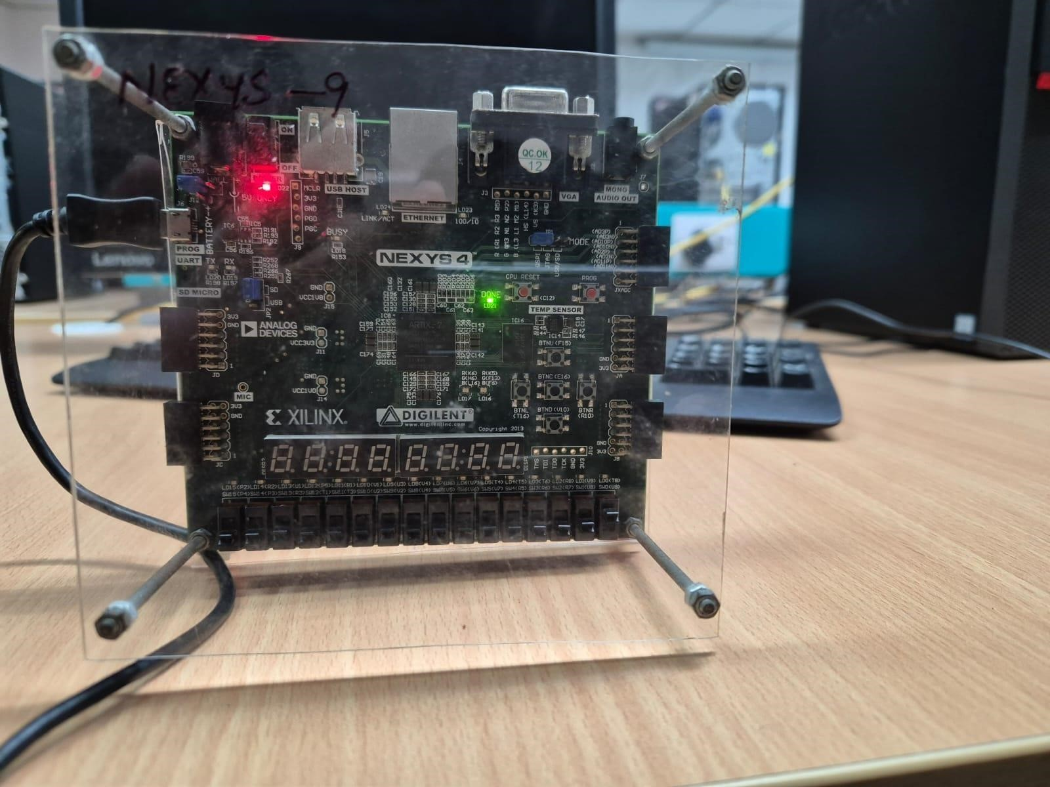

Fig: FPGA

Future Work:

* Code can be written which helps in taking input from the temperature sensor on the FPGA.
* Interfacing the light and motion sensor to the FPGA.
* Making provisions so that the user can connect to the home automation system through their mobile phones.

Results and Conclusion:

In conclusion, we can say that we have successfully developed a comprehensive flow chart outlining the fundamental operations of a home automation system. Additionally, we have efficiently implemented this flow chart into a Verilog code. The initial stages of testing have been completed successfully, validating the functionality of our code.

Fig

3

.a: Code

for

home_automation

module

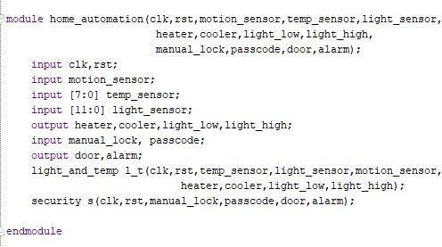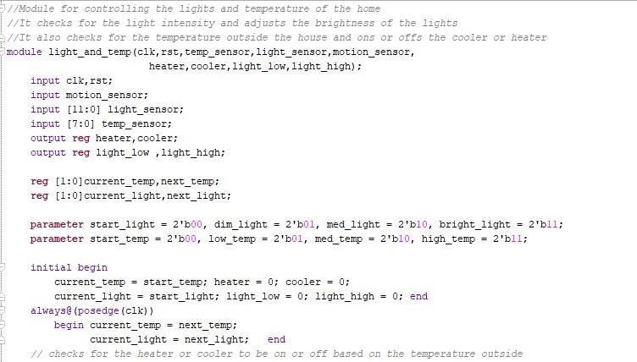

Fig 3.b: Code for light and temp module

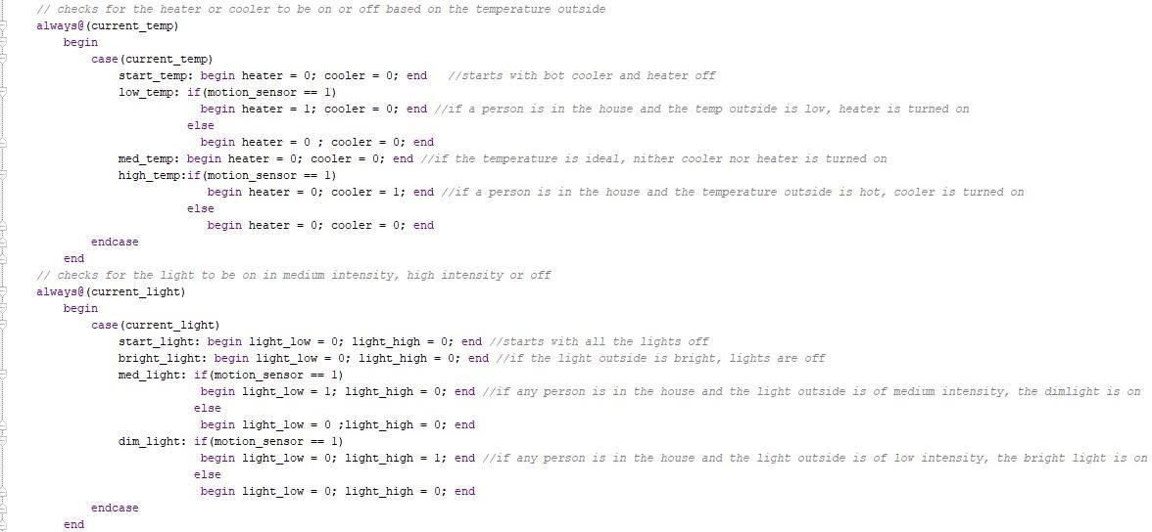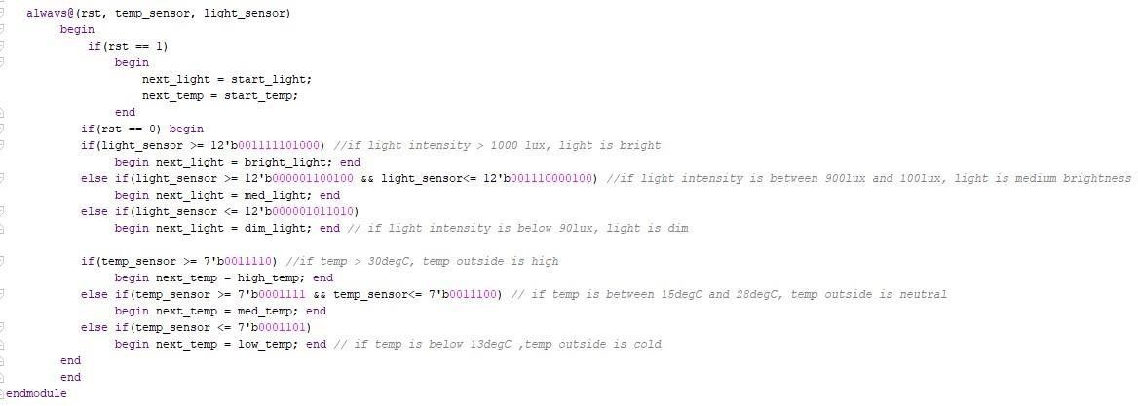

Fig 3.b: Code for light and temp module (continued)

Fig

3

.c

:

Code

for security

module

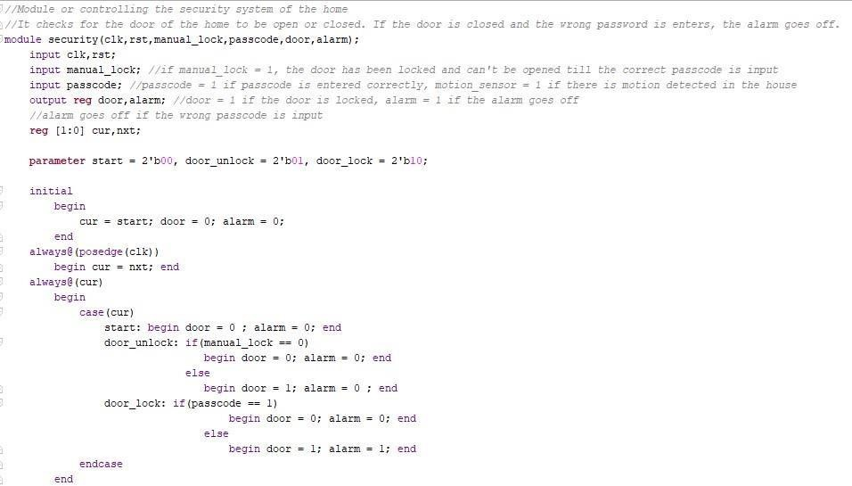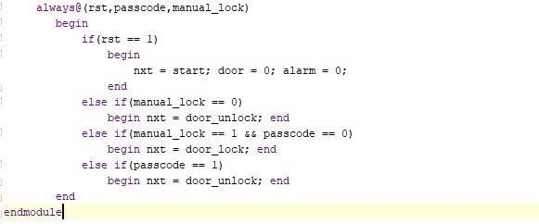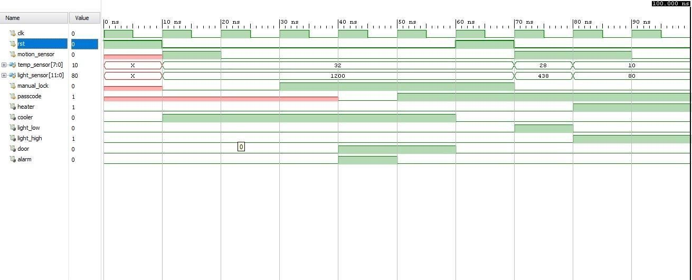

Fig 4: Output waveform

In conclusion, our project has demonstrated successful progress in designing and implementing a basic home automation system. With testing and implementation on FPGA, we had achieve our project objectives effectively.

References:

1. Komol Arafat Gani, Farzana Yasmin, A B M Najmul Karim, Iqbalur Rahman,

“Home Automation System Design Using Verilog Hardware Descriptive Language”, (ICRTCIE'2013) Dec 20-21, 2013 Bali (Indonesia)

1. Chee-Pun. Ooi, Wooi-Haw. Tan, Soon-Nyean. Cheong, Yee-Lien. Lee, V. M.

Baskaran, Yeong-Liang. Low, “FPGA-based embedded architecture for IoT home automation application”, Indonesian Journal of Electrical Engineering and Computer Science, Vol.14, No.2, May 2019, pp. 646~652

1. Santosh Wagaj, Pooja More, “IOT based home automation system using

FPGA”, International Journal of Advances in Engineering and Management (IJAEM) Volume 3, Issue 7 July 2021, pp: 2180-2182

1. Tanvi Gurav, Ibrahim Gaonkhadkar, Soham Deolekar, Yash Dhanawade,

Rashmi Kulkarni, “IOT BASED HOME AUTOMATION USING FPGA”,

2022 IJCRT, Volume 10, Issue 4 April 2022

